Extension_sample.py
Input: ‘unique files.csv’
(all google ids and metadata, all file extensions)
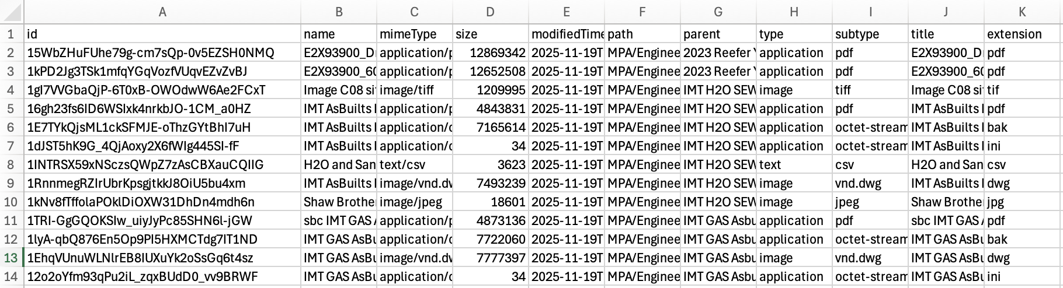
Output: ‘‘docx [i] [i+50].csv’
(50-file long lists of google id and metadata for extension = docx)
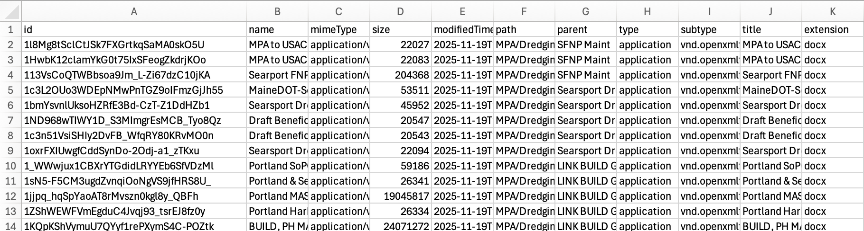
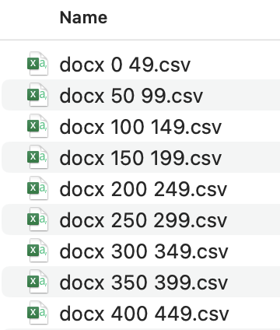

Sample_corpus.py
Input: ‘docx [i] [i+50].csv’
(list of csvs containing 50-row file ids and metadata)
Output: ‘tokenized docx [i] [i+50].csv’
( tokenized dfs of 50-files each )
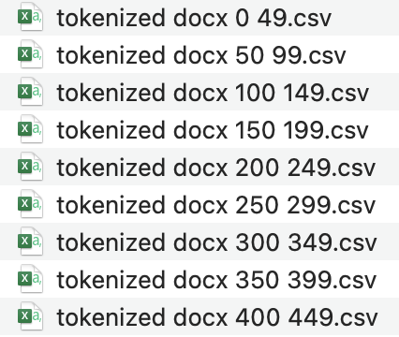
Methods-
docx_reader(): reads file from API into a memory object
word_cleaner(): cleans and tokenizes strings as lemmas
tokenizer(): builds dictionary as {google id: tokenized document as df} pairs
token_saver(): concatenates dictionary to a dataframe and exports to csv

Corpus_builder.py
Input: ‘tokenized docx [i] [i+50].csv’
(list of tokenized dfs)
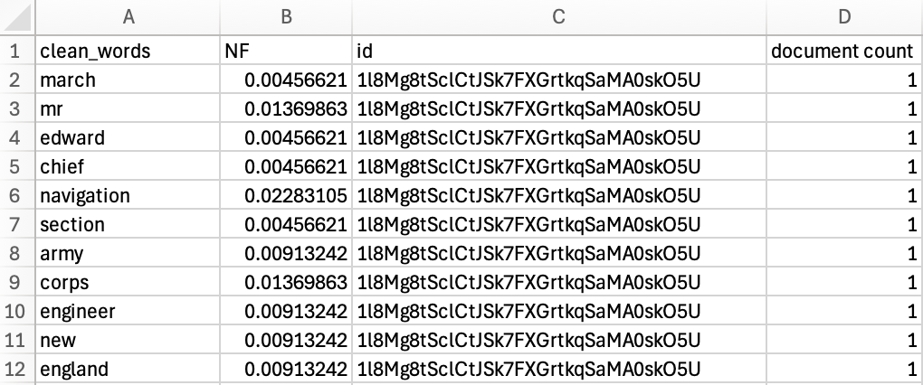
Output: ‘tokenized docx corpus.csv’
Concatenates files into single corpus, ~160,000 rows long
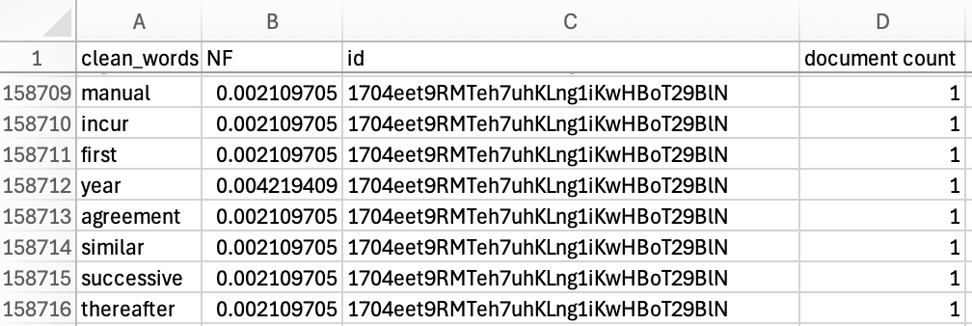

Corpus_vectorizer.py
Input: ‘tokenized docx corpus.csv’
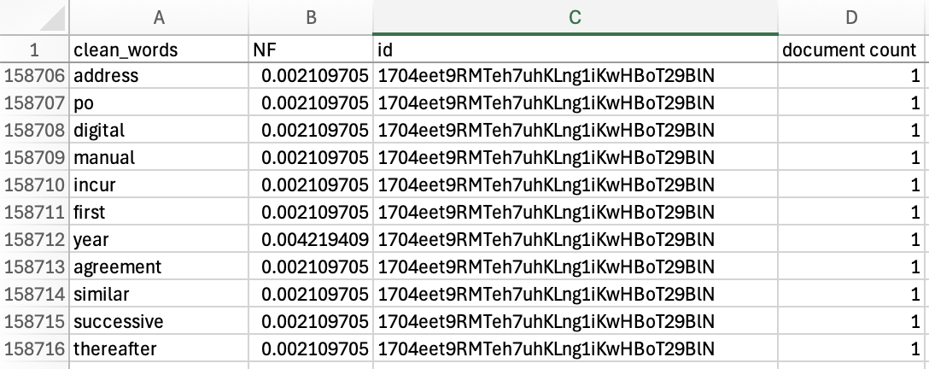
Intermediate step: ‘corpus counts df.csv’
(data for analysis are ‘clean_words’, ‘id’, ‘NF * IDF’ columns)
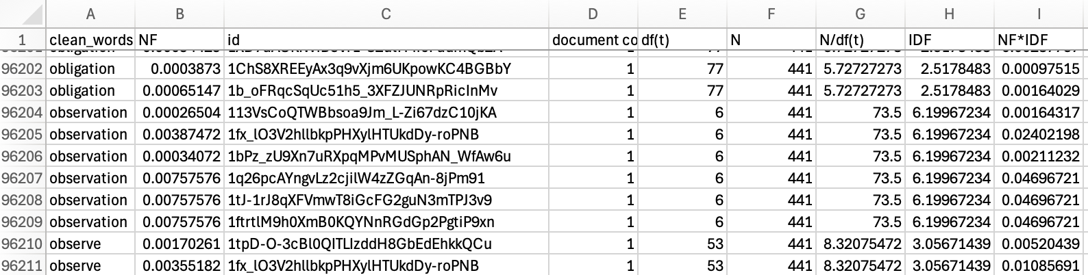

Output: ‘vectorized docx corpus.csv’
(400+ docx files in Feature Vector Form in terms of 9,000+ token parameters)
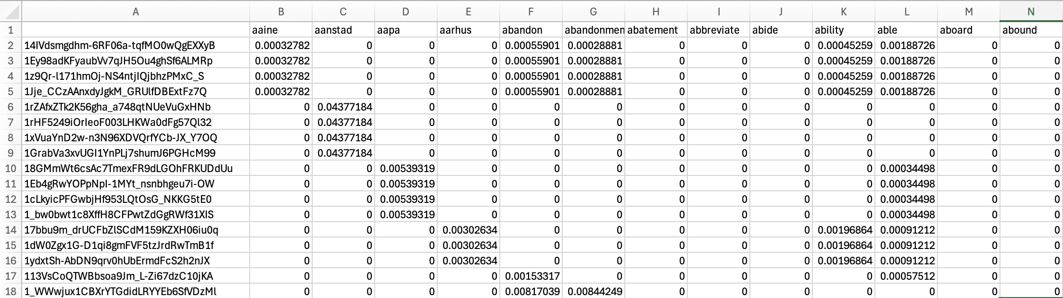

Clustering.py
Methods:
Elbow_graph(): find optimal # of clusters for scikitlearn K-Means algorithm
Cluster_indexer(): assign cluster numbers to documents
Input: 'vectorized docx corpus.csv'
(vectorized documents)
Output: ‘clustered docx vectors.csv’
(vectorized documents with cluster index assigned to each google id)
The elbow graph indicated 160 clusters for the full docx corpus, but with less than 500 documents that doesn’t achieve the goal of organizing the files.
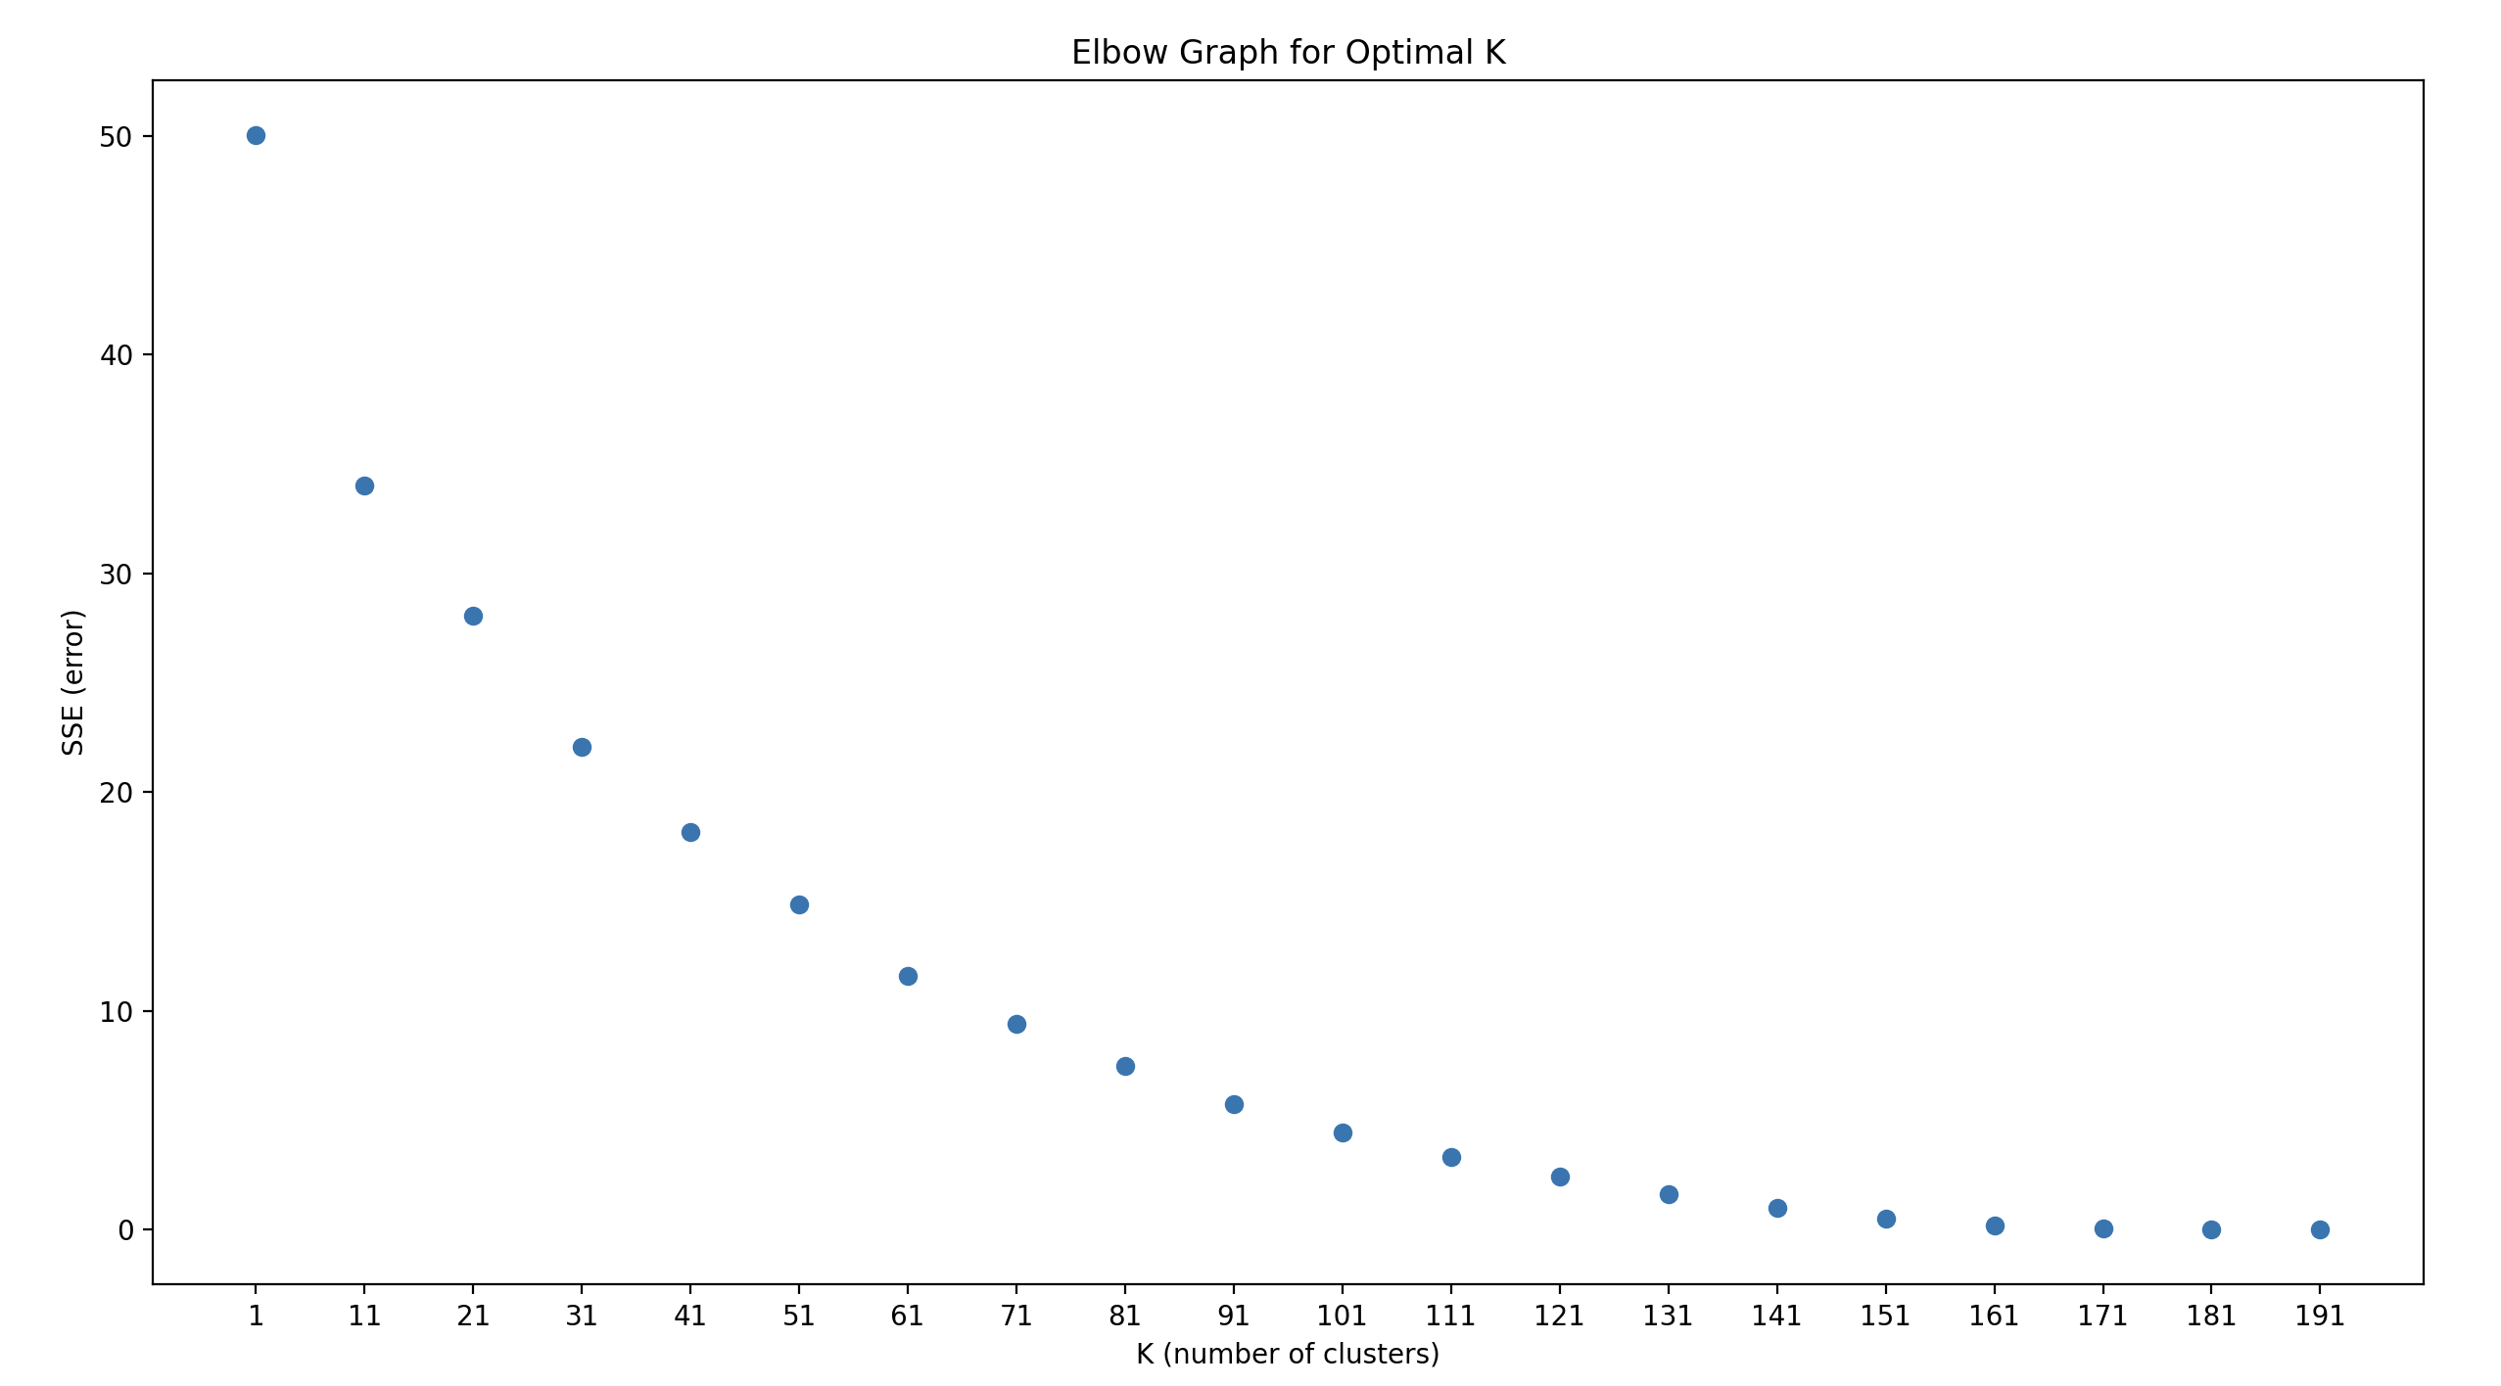
Therefore, we experimented by creating 10, 15, and 30 clusters and checking the results. What this revealed was that our earlier method to remove duplicate files was not effective, because there are duplicate files with 1 or 2 KB differences in size:
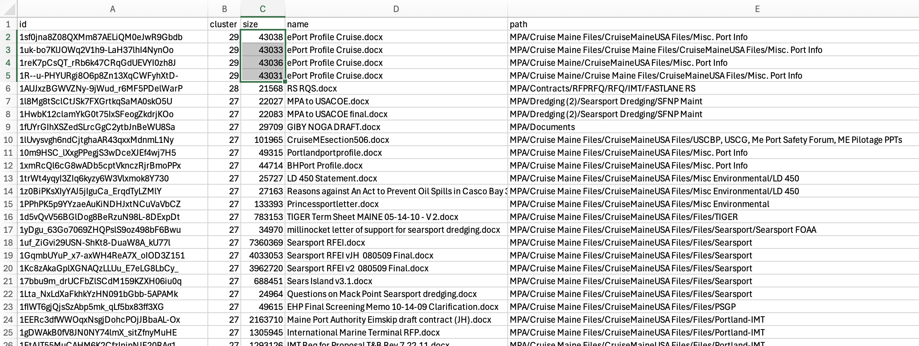
These duplicates corrupted our attempt to generate meaningful clusters. As you can see above, cluster 29 was made up of duplicates, while cluster 27 had over 100 dissimilar files. This also explains why it was possible to continue reducing the error up to 160 clusters: there are probably around 160 instances of duplicate docx files.

Clustering_less_dupey.py
Input: 'vectorized docx corpus less dupey.csv'
(200 vectorized documents)
Output: ‘clustered docx vectors less dupey.csv’
(vectorized documents with cluster index assigned to each google id)
The elbow graph again indicated an unacceptably high number of clusters, over 100 clusters on 200 data points, was required to reduce error.
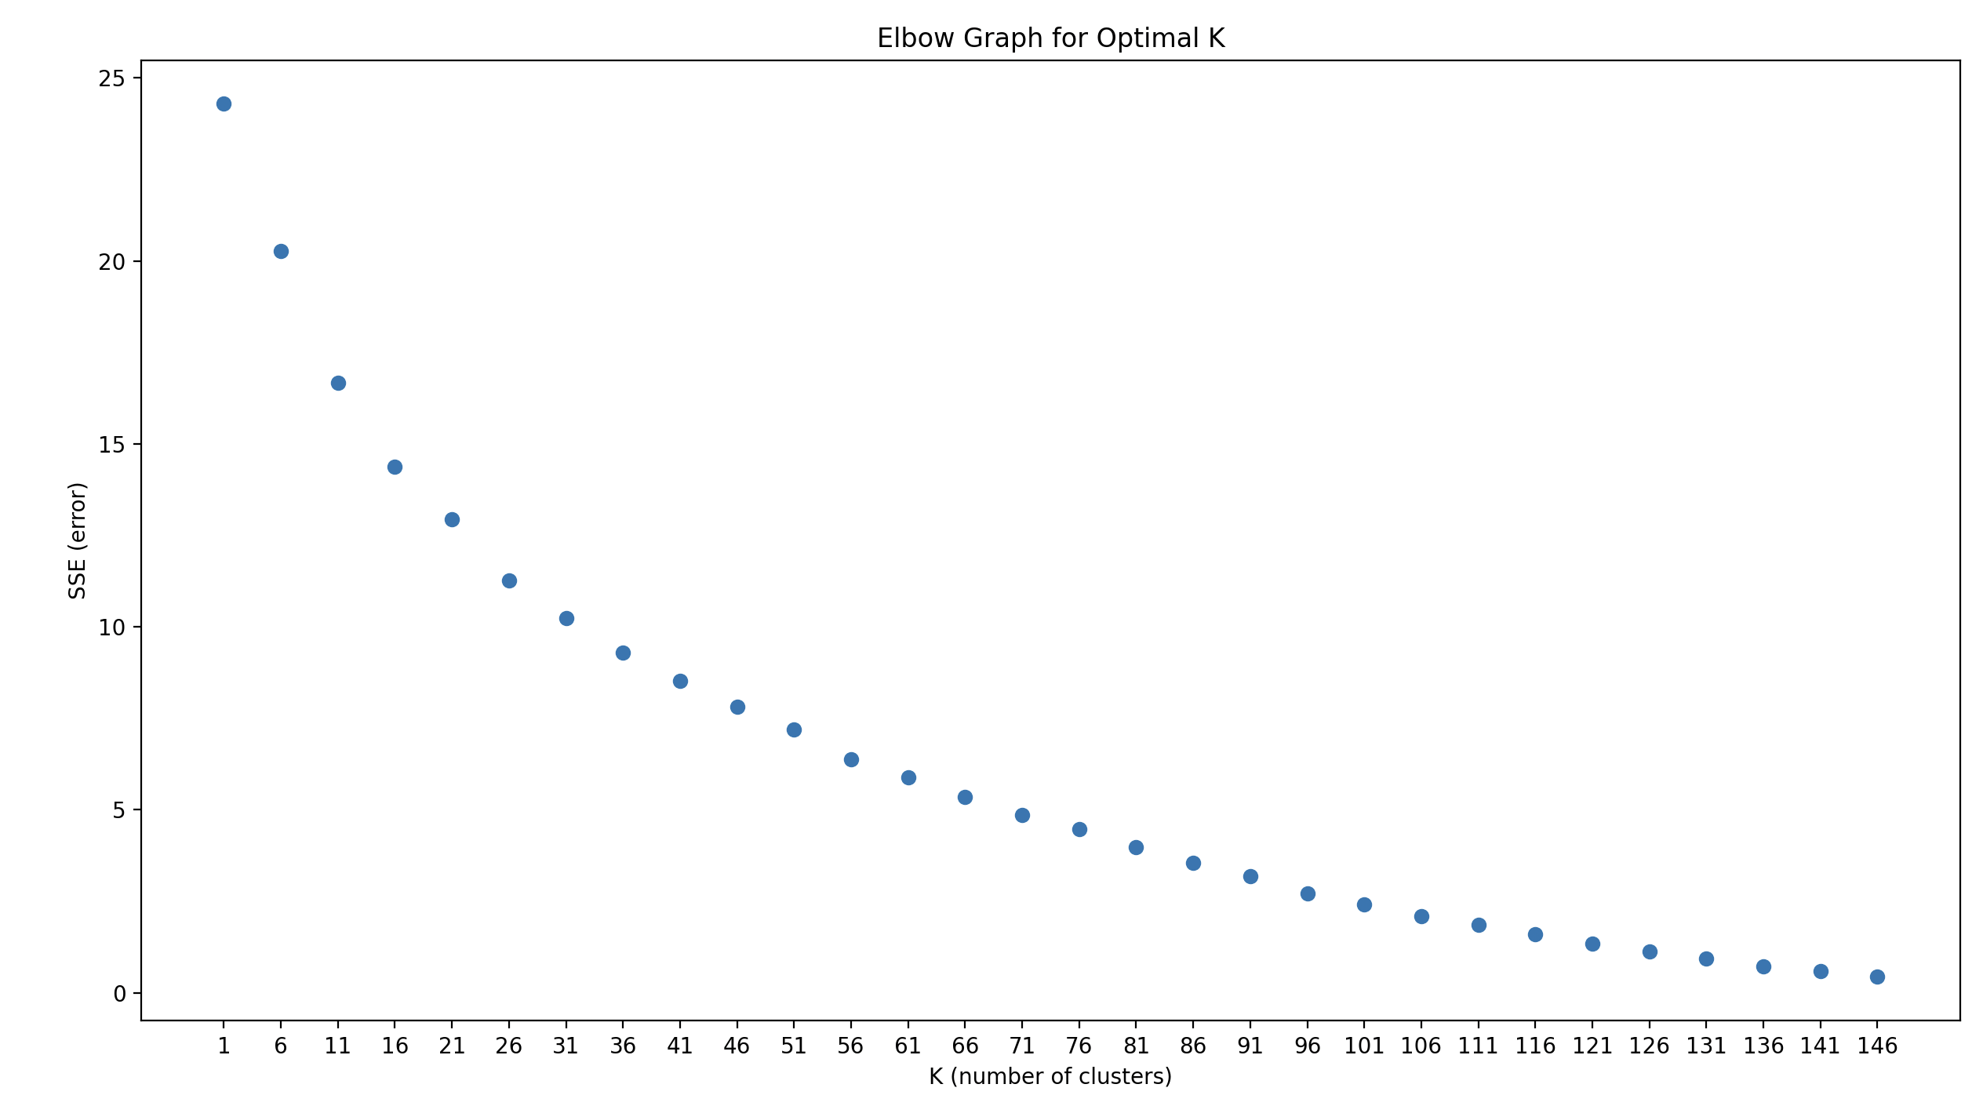
Nonetheless, we explored 15 clusters for any meaning in the relationships. With 15 clusters, however, we found 127 documents being grouped into a single cluster, 55 documents in another cluster, while many other clusters contained only 1or 2 entries. This was not the result we hoped for.

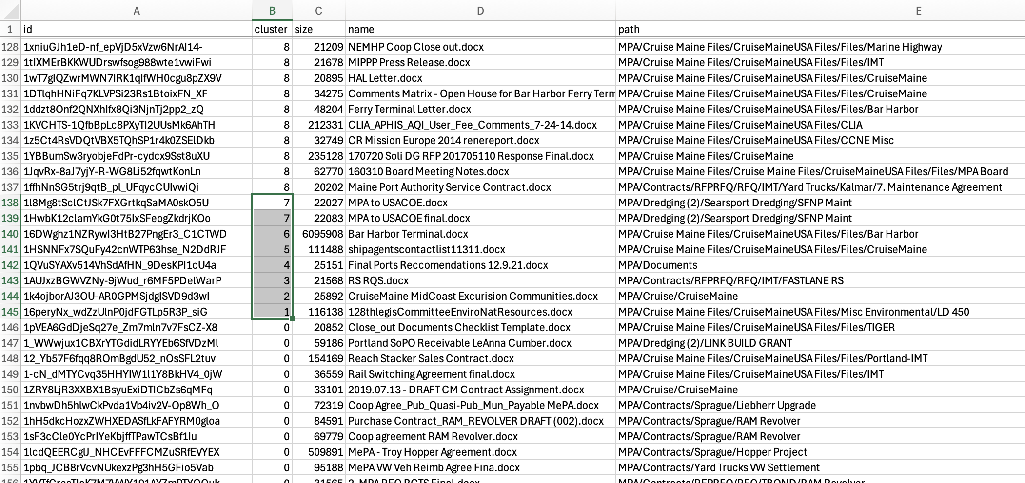

The best conclusion we can draw from this is that the files are not suited to be studied as data points in a textual analysis, most likely due to the small size of the corpus, relative to real-world use cases with millions of documents.

